

**Internet and Web Programming**

**Lab Digital Assignment – II**

**Name:** Manvendra Gosain

**Registration Number:** 22MCA0321

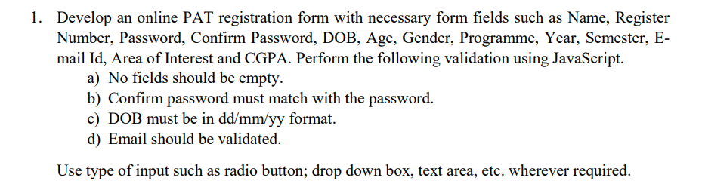

**index.html:**

<!DOCTYPE html>

<html lang="en">

  <head>

    <meta charset="UTF-8" />

    <meta name="viewport" content="width=device-width, initial-scale=1.0" />

    <title>PAT Registration Form</title>

    <link rel="stylesheet" href="./style.css" />

  </head>

  <body>

    <div class="container">

      <form id="registrationForm">

        <h2>PAT Registration Form</h2>

        <div class="form-group">

          <label for="name">Name:</label>

          <input type="text" id="name" required />

        </div>

        <div class="form-group">

          <label for="registerNumber">Register Number:</label>

          <input type="text" id="registerNumber" required />

        </div>

        <div class="form-group">

          <label for="password">Password:</label>

          <input type="password" id="password" required />

        </div>

        <div class="form-group">

          <label for="confirmPassword">Confirm Password:</label>

          <input type="password" id="confirmPassword" required />

        </div>

        <div class="form-group">

          <label for="dob">DOB (dd/mm/yy):</label>

          <input type="text" id="dob" required />

        </div>

        <div class="form-group">

          <label for="age">Age:</label>

          <input type="number" id="age" required />

        </div>

        <div class="form-group" style="justify-content: space-between">

          <label>Gender:</label>

          <label for="male"

            >Male

            <input type="radio" id="male" name="gender" value="Male" required

          /></label>

          <label for="female"

            >Female

            <input

              type="radio"

              id="female"

              name="gender"

              value="Female"

              required

          /></label>

          <label for="other"

            >Other

            <input type="radio" id="other" name="gender" value="Other" required

          /></label>

        </div>

        <div class="form-group">

          <label for="programme">Programme:</label>

          <select id="programme" required>

            <option value="">Select Programme</option>

            <option value="B.Tech">B.Tech</option>

            <option value="M.Tech">M.Tech</option>

            <option value="Ph.D.">Ph.D.</option>

          </select>

        </div>

        <div class="form-group">

          <label for="year">Year:</label>

          <input type="number" id="year" required />

        </div>

        <div class="form-group">

          <label for="semester">Semester:</label>

          <input type="number" id="semester" required />

        </div>

        <div class="form-group">

          <label for="email">Email:</label>

          <input type="email" id="email" required />

        </div>

        <div class="form-group">

          <label for="areaOfInterest">Area of Interest:</label>

          <textarea id="areaOfInterest" required></textarea>

        </div>

        <div class="form-group">

          <label for="cgpa">CGPA:</label>

          <input type="number" id="cgpa" step="0.01" required />

        </div>

        <div class="form-group">

          <button type="submit" onclick="validateForm()">Submit</button>

        </div>

      </form>

    </div>

    <script src="./script.js"></script>

  </body>

</html>

**style.css:**

@import url('https://fonts.googleapis.com/css2?family=Roboto:wght@400;700&display=swap');

body {

    display: flex;

    justify-content: center;

    align-items: center;

    height: 100vh;

    margin: 0;

    background: url('./bg.jpg') no-repeat center center fixed;

    font-family: 'Roboto', sans-serif;

}

.container {

    background: rgba(255, 255, 255, 0.13);

    border-radius: 20px;

    padding: 30px 50px;

    width: 500px;

    box-shadow: 0 4px 32px 0 rgba(255, 255, 255, 0.39);

    backdrop-filter: blur(5px);

    border: 1px solid rgba(255, 255, 255, 0.349);

    height: 90%;

    color: black;

}

h2 {

    text-align: center;

    margin-bottom: 20px;

}

.form-group {

    margin-bottom: 20px;

    display: flex;

    flex-direction: row;

    align-items: center;

}

label {

    font-weight: bold;

    margin-right: 10px;

*/* Add spacing between label and input */*

    flex-basis: 100px;

*/* Set fixed width for labels */*

}

input[type="text"],

input[type="password"],

input[type="number"],

input[type="email"],

select,

textarea {

    flex: 1;

    padding: 10px;

    border: 1px solid #62a9e494;

    border-radius: 5px;

    background: rgba(255, 255, 255, 0.2);

}

textarea {

    resize: none;

}

.button-group {

    display: flex;

    justify-content: space-between;

    align-items: center;

}

button {

    background: rgba(255, 255, 255, 0.13);

    border: none;

    border-radius: 5px;

    padding: 12px 20px;

    cursor: pointer;

    width: 100%;

    font-size: 16px;

    font-weight: 700;

    transition: 1s ease-in-out;

}

button:hover {

    background: rgba(255, 255, 255, 0.5);

}

.error-message {

    color: red;

    font-size: 12px;

    margin-top: 5px;

}

**script.js:**

document.addEventListener('DOMContentLoaded', () **=>** {

**const** form = document.getElementById('registrationForm');

    form.addEventListener('submit', (e) **=>** {

        e.preventDefault();

        clearErrors();

        if (!validateForm()) {

            return;

        }

        alert('Registration successful!');

    });

**function** validateForm() {

**let** isValid = true;

**const** name = document.getElementById('name').value.trim();

**const** registerNumber = document.getElementById('registerNumber').value.trim();

**const** password = document.getElementById('password').value.trim();

**const** confirmPassword = document.getElementById('confirmPassword').value.trim();

**const** dob = document.getElementById('dob').value.trim();

**const** email = document.getElementById('email').value.trim();

**const** cgpa = parseFloat(document.getElementById('cgpa').value.trim());

        if (name === '' || registerNumber === '' || password === '' || confirmPassword === '' ||

            dob === '' || email === '' || cgpa === NaN) {

            alert('All fields are required.');

            isValid = false;

        }

        if (password !== confirmPassword) {

            alert('Passwords do not match.');

            isValid = false;

        }

        if (!dob.match(/^\d{2}\/\d{2}\/\d{2}$/)) {

            alert('DOB must be in dd/mm/yy format.');

            isValid = false;

        }

        if (!validateEmail(email)) {

            alert('Invalid email format.');

            isValid = false;

        }

        return isValid;

    }

**function** validateEmail(email) {

**const** emailPattern = /^[^\s@]+@[^\s@]+\.[^\s@]+$/;

        return emailPattern.test(email);

    }

**function** displayError(message) {

**const** errorMessage = document.createElement('div');

        errorMessage.className = 'error-message';

        errorMessage.textContent = message;

        form.appendChild(errorMessage);

    }

**function** clearErrors() {

**const** errorMessages = document.querySelectorAll('.error-message');

        errorMessages.forEach((message) **=>** message.remove());

    }

});

